**The ERD of the hospital database:**

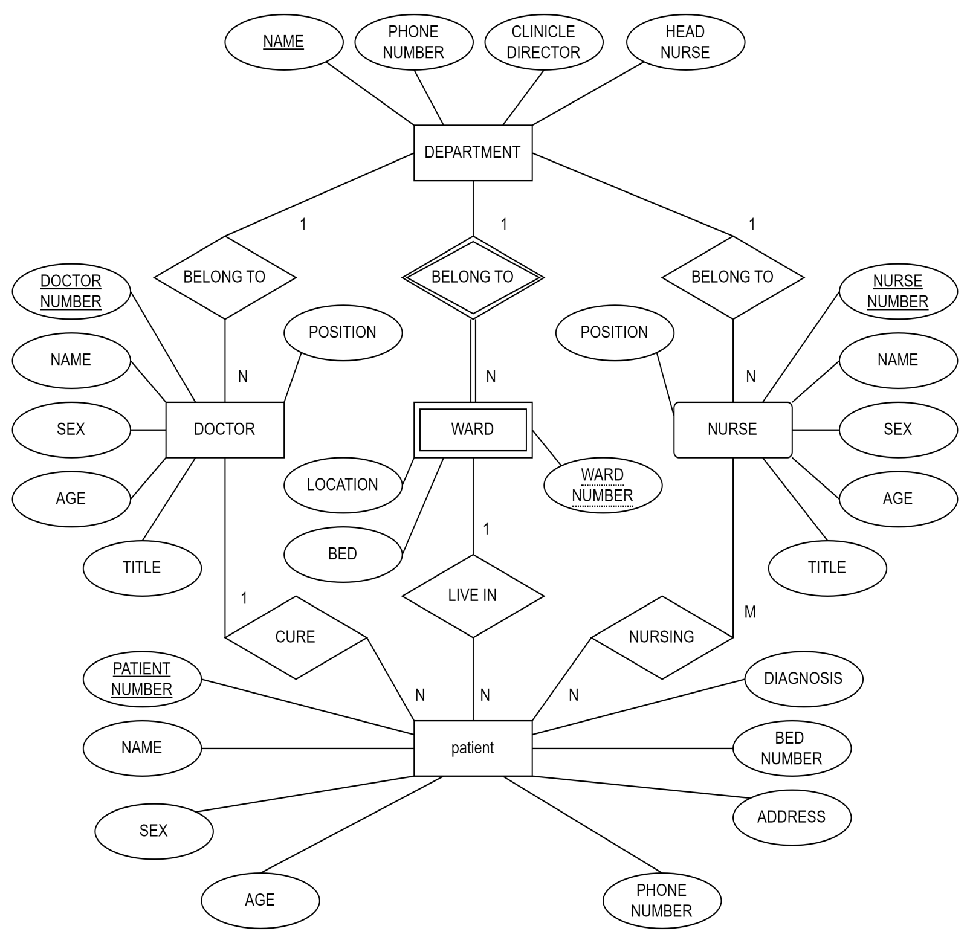

**Assumption:**

**Names of departments are unique.**

**Numbers of wards are not unique.**

**Each patient is managed and treated by only one doctor, managed by one nurse, but can be cared for by several nurses.**

**The SCHEMA of the hospital database:**

**Department Schema:**



**Doctor Schema:**



**Nurse Schema:**



**Nursing Schema:**



**Patient Schema:**





**Ward Schema:**

